Foreign key

Foreign key is a column in one table that refers to tha primary key of another table.the foreign key in two types.

*ON DELETE SET NULL
*ON DELETE CASCADE

- On Delete Set Null:
ON DELETE SET NULL is a foreign key action that sete the foreign key value to NULL when the related record in the parent table is deleted.this helps keep the child record without breaking the relationship rules.

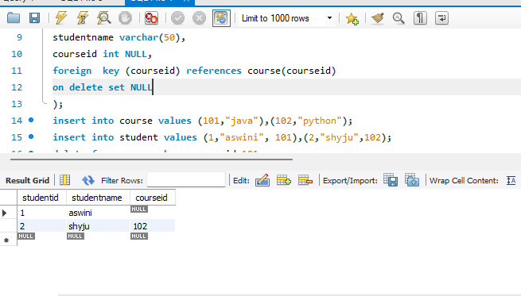

- On Delete CasCade

ON DELETE CASCADE is a foreign key action that automatically deletes all related records in the child table when a record in the parent table is deleted.this help maintain referntial integrity and prevents orphan records.

